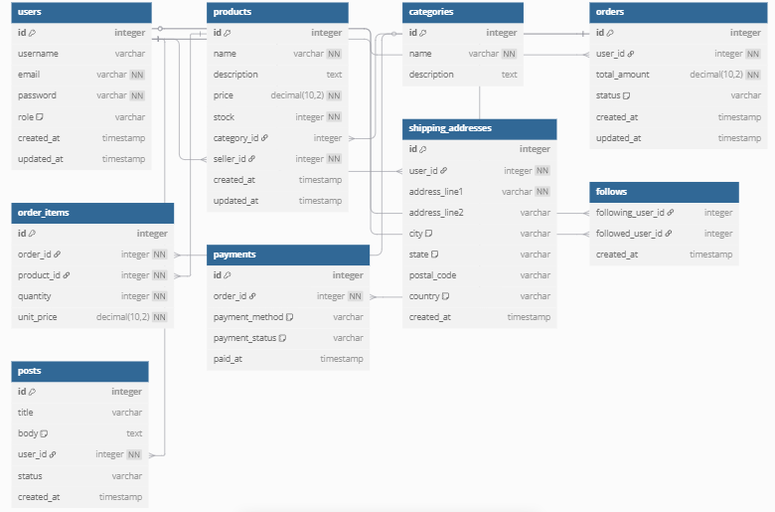

// Esquema de base de datos para Qūshi E-commerce

Table users {

id integer [primary key]

username varchar

email varchar [unique, not null]

password varchar [not null]

role varchar [note: 'customer, admin, seller']

created_at timestamp

updated_at timestamp

}

Table products {

id integer [primary key]

name varchar [not null]

description text

price decimal(10,2) [not null]

stock integer [not null]

category_id integer

seller_id integer [not null] // vendedor que publicó el producto

created_at timestamp

updated_at timestamp

}

Table categories {

id integer [primary key]

name varchar [not null]

description text

}

Table orders {

id integer [primary key]

user_id integer [not null]

total_amount decimal(10,2) [not null]

status varchar [note: 'pending, paid, shipped, delivered, cancelled']

created_at timestamp

updated_at timestamp

}

Table order_items {

id integer [primary key]

order_id integer [not null]

product_id integer [not null]

quantity integer [not null]

unit_price decimal(10,2) [not null]

}

Table payments {

id integer [primary key]

order_id integer [not null]

payment_method varchar [note: 'credit_card, paypal, transfer, cash_on_delivery']

payment_status varchar [note: 'pending, completed, failed']

paid_at timestamp

}

Table shipping_addresses {

id integer [primary key]

user_id integer [not null]

address_line1 varchar [not null]

address_line2 varchar

city varchar [default: 'Cali']

state varchar [default: 'Valle del Cauca']

postal_code varchar

country varchar [default: 'Colombia']

created_at timestamp

}

Table follows {

following_user_id integer

followed_user_id integer

created_at timestamp

}

Table posts {

id integer [primary key]

title varchar

body text [note: 'Content of the post']

user_id integer [not null]

status varchar

created_at timestamp

}

// Relaciones

Ref: posts.user_id > users.id

Ref: follows.following_user_id > users.id

Ref: follows.followed_user_id > users.id

Ref: products.category_id > categories.id

Ref: products.seller_id > users.id

Ref: orders.user_id > users.id

Ref: order_items.order_id > orders.id

Ref: order_items.product_id > products.id

Ref: payments.order_id > orders.id

Ref: shipping_addresses.user_id > users.id